Human IL-2RA Protein; hFc Tag

Product Information
Product Name | Human IL-2RA Protein; hFc Tag
Storage temp | Store at ≤ -70℃, stable for 6 months after receipt. Recommend to aliquot the protein into smaller quantities for optimal storage. Please minimize freeze-thaw cycles.
Catalog# / Size | GM-88752RP-100 / 100 μg  GM-88752RP-1000 / 1 mg

Protein Information
Alternative Names | IL2RA, CD25, p55, IL2-RA, IL-2-RA
Source | Human IL-2RA Protein; hFc Tag (GM-88752RP) is expressed from human 293 cells (HEK-293). It contains AA Glu 22 - Cys 213 (Accession # NP_000408.1).This protein carries a hFc tag at the C-terminus.
Purity | > 90% as determined by SDS-PAGE
Endotoxin | < 1 EU/μg, determined by LAL gel clotting assay
Predicted Mol Mass | 47.7 kDa
Formulation | Supplied as a 0.2 μm filtered solution of PBS, pH 7.2–7.4.
Description | IL-2 receptor alpha chain (IL-2Rα), also known as CD25, is the high-affinity component of the IL-2 receptor complex. It is predominantly expressed on activated T cells, regulatory T cells (Tregs), and certain other immune cells, where it functions to capture IL-2 and present it to the IL-2 receptor ensemble. IL-2Rα itself does not signal; it associates with IL-2Rβ (CD122) and the common gamma chain (γc, CD132) to form the functional trimeric receptor, enabling downstream signaling that drives T cell proliferation, survival, and differentiation in response to IL-2.Upon IL-2 binding to the high-affinity receptor complex including IL-2Rα, receptor-associated tyrosine kinases JAK1 and JAK3 are activated, leading to phosphorylation of STAT5 and other substrates. Phosphorylated STAT5 dimerizes and translocates to the nucleus to drive transcription of genes involved in cell cycle progression (e.g., Cyclin D2), anti-apoptotic signaling, and metabolic reprogramming.

Figures
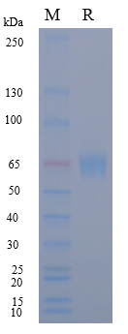
Figure 1 | On SDS-PAGE under reducing (R) condition. The gel was stained overnight with Coomassie Blue. The purity of the protein is greater than 90%.

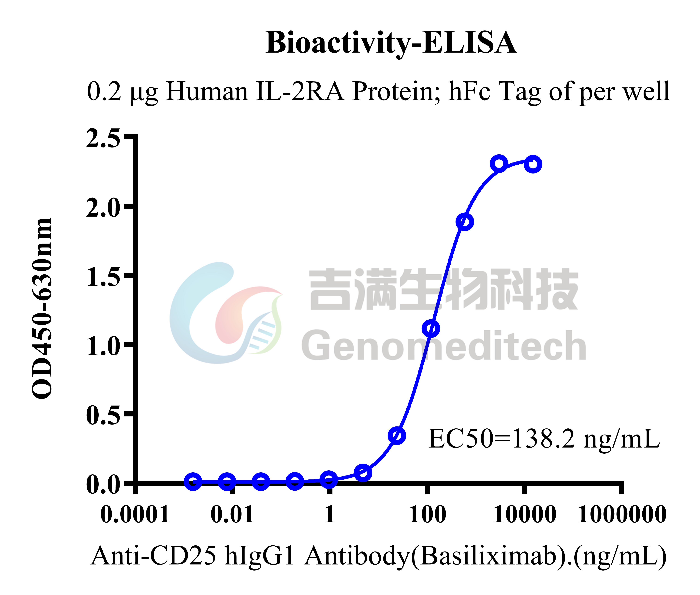
Figure 2 | Human IL-2RA Protein; hFc Tag (Catalog # GM-88752RP) was immobilized at 2 μg/ml (100 μL/well). Increasing concentrations of Anti-CD25 hIgG1 Antibody(Basiliximab) (Catalog # GM-52329AB) were added.

Related Products
IL-15
H_IL15 Reporter Cell Line | Cynomolgus_CD122 HEK-293 Cell Line
H_CD122 CD132 CHO-K1 Cell Line | H_CD122 CHO-K1 Cell Line
H_CD122 HEK-293 Cell Line | H_CD215(IL15RA) HEK-293 Cell Line
IL-2
H_CD122 CD132 Reporter 293 Cell Line | H_CD122 CD132 Reporter Cell Line
H_CD25 CD122 CD132 Reporter Cell Line | H_CD25 CD122 CD132 Reporter Jurkat(hPD1 OE) Cell Line
H_IL2 Reporter Cell Line | H_IL2 Reporter DDX35TM Cell Line
Cynomolgus_CD25 HEK-293 Cell Line | H_CD25 CHO-K1 Cell Line
H_CD25 HEK-293 Cell Line
Anti-CD122 hIgG1 Antibody(HuABC-2) | Anti-CD132(IL2RG) hIgG4 Antibody(REGN7257)
Anti-CD25 hIgG1 Antibody(Basiliximab) | Anti-IL2 hIgG1 Antibody (imneskibart)
Anti-mouse CD25 mIgG2a Antibody(PC-61.5.3) | Anti-mouse CD25 RIgG1 Antibody(PC-61.5.3)
Anti-PD1-IL2v Fusion hIgG1 Antibody(2149) | Anti-PD1-IL2v Fusion hIgG1 Antibody(KY-0118)
Cynomolgus IL-2 Protein; His Tag | Cynomolgus IL-2RA Protein; hFc Tag
Cynomolgus IL-2RA Protein; His Tag | Cynomolgus IL-2RB Protein; His Tag
Human IL-2 Protein; hFc Tag | Human IL-2 Protein; His Tag
Human IL-2RA Protein; His Tag | Human IL-2RB Protein; His Tag
Human IL-2RG Protein; His Tag

