Cynomolgus IL-1RL1(IL-33R) Protein; His Tag

Product Information
Product Name | Cynomolgus IL-1RL1(IL-33R) Protein; His Tag
Storage temp | Store at ≤ -70℃, stable for 6 months after receipt. Recommend to aliquot the protein into smaller quantities for optimal storage. Please minimize freeze-thaw cycles.
Catalog# / Size | GM-88801RP-100 / 100 μg  GM-88801RP-1000 / 1 mg

Protein Information
Alternative Names | DER4, FIT-1, IL33R, ST2, ST2L, ST2V, T1
Source | Cynomolgus IL-1RL1(IL-33R) Protein; His Tag is expressed from human 293 cells (HEK-293). It contains AA Ala18-Cys331 (Accession # A0A2K5UDB8).This protein carries a His tag at the C-terminus.
Purity | > 95% as determined by SDS-PAGE
Endotoxin | < 1 EU/μg, determined by LAL gel clotting assay
Predicted Mol Mass | 36.5 kDa
Formulation | Supplied as a 0.2 μm filtered solution of PBS, pH 7.2–7.4.
Description | IL-1RL1 (also known as ST2) is a transmembrane receptor of the interleukin-1 receptor superfamily, expressed on mast cells, Th2 cells, and innate lymphoid cells (ILC2s). It binds to its ligand IL-33 on epithelial cells and endothelial cells, promoting type 2 immune responses, eosinophilic inflammation, and tissue repair in allergic and inflammatory conditions. In summary, IL-1RL1 is a key receptor for IL-33 signaling with biomarker and therapeutic potential in asthma, atopic dermatitis, and cardiovascular diseases.

Figures
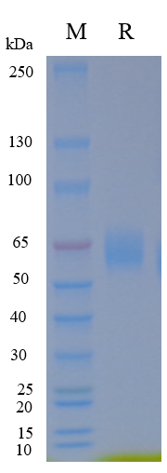
Figure 1 | On SDS-PAGE under reducing (R) condition. The gel was stained overnight with Coomassie Blue. The purity of the protein is greater than 95%.

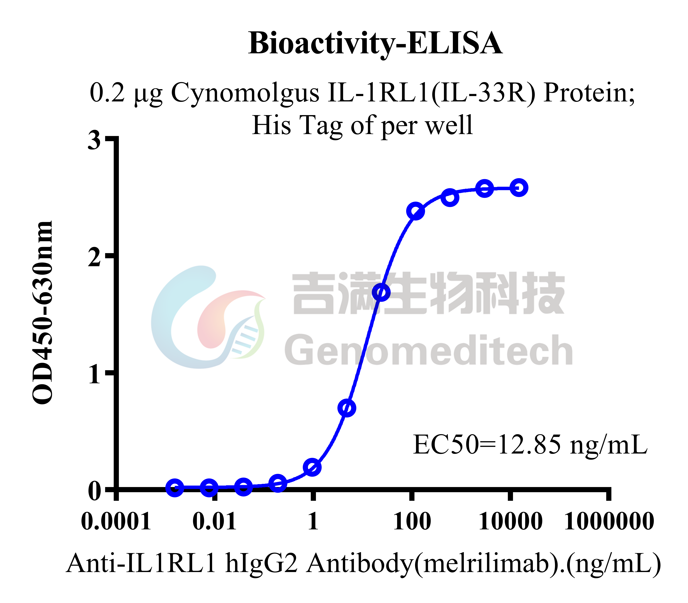
Figure 2 | Cynomolgus IL-1RL1(IL-33R) Protein; His Tag (Catalog # GM-88801RP) was immobilized at 2 μg/ml (100 μL/well). Increasing concentrations of Anti-IL1RL1 hIgG2 Antibody(melrilimab) (Catalog # 88366AB) were added.

Related Products
IL-33
H_IL-33 Reporter 293 Cell Line | H_IL33 Reporter 293 Cell Line (old version)
Cynomolgus_IL33R HEK-293 Cell Line | H_IL33R CHO-K1 Cell Line
H_IL33R HEK-293 Cell Line
Anti-IL33 hIgG4 Antibody(Itepekimab) | Anti-IL33 hIgG4 Reference Antibody (Itepbio)
Human IL-1RL1(IL-33R) Protein; hFc Tag | Human IL-1RL1(IL-33R) Protein; His Tag
Human IL-33 (C208S,C227S,C232S,C259S) Protein; His Tag | Human IL-33 Protein; His Tag

