Human IL-7 Protein; hFc Tag

Product Information
Product Name | Human IL-7 Protein; hFc Tag
Storage temp | Store at ≤ -70℃, stable for 6 months after receipt. Recommend to aliquot the protein into smaller quantities for optimal storage. Please minimize freeze-thaw cycles.
Catalog# / Size | GM-88677RP-100 / 100 μg  GM-88677RP-1000 / 1 mg

Protein Information
Alternative Names | IL7, Interleukin-7
Source | Human IL-7 Protein; hFc Tag (GM-88677RP) is expressed from human 293 cells (HEK-293). It contains AA Asp 26 - His 177 (Accession # P13232).This protein carries a hFc tag at the C-terminus.
Purity | > 90% as determined by SDS-PAGE
Endotoxin | < 1 EU/μg, determined by LAL gel clotting assay
Predicted Mol Mass | 43.3 kDa
Formulation | Supplied as a 0.2 μm filtered solution of PBS, pH 7.2–7.4.
Description | IL-7 (Interleukin-7) is an important cytokine produced by various cells, primarily involved in the development and maintenance of the immune system. It plays a key role in promoting the growth, survival, and maturation of T cells, and also participates in B cell differentiation, which is vital for maintaining normal immune function. IL-7 exerts its effects by binding to its receptor, IL-7R, activating downstream signaling pathways that regulate the quantity and function of immune cells.  IL-7 has shown great potential in clinical research, especially in the treatment of immune deficiency diseases, autoimmune disorders, and certain types of cancer. Because of its ability to enhance immune responses, IL-7 is viewed as a promising immunomodulator. However, excessive activity of IL-7 can lead to immune system imbalance, so careful regulation is necessary in its application to ensure safe and effective treatment results.

Figures
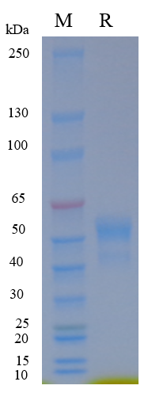
Figure 1 | On SDS-PAGE under reducing (R) condition. The gel was stained overnight with Coomassie Blue. The purity of the protein is greater than 90%.

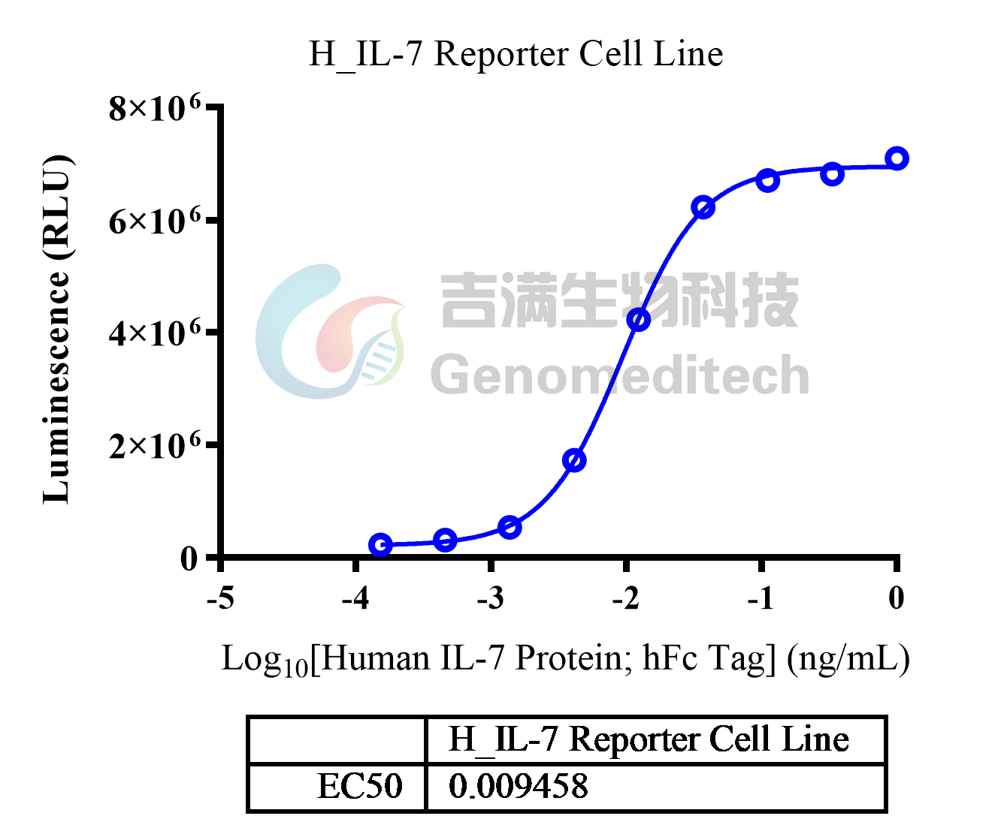
Figure 2 | Human IL-7 Protein; hFc Tag (Catalog # GM-88677RP) was added into H_IL-7 Reporter Cell Line (Catalog # GM-C30922) and stimulates related signals.

Related Products
IL-7
H_IL-7 Reporter Cell Line | Cynomolgus_IL7R HEK-293 Cell Line
H_IL7R CHO-K1 Cell Line | H_IL7R HEK-293 Cell Line
Anti-H_IL-7Rα hIgG4 Antibody(lusvertikimab) | Anti-IL7Ra hIgG1 Antibody(4A10)
Human IL-7 Protein; His Tag | Human IL-7RA Protein; His Tag

