Cynomolgus IL-2 Protein; hFc Tag

Product Information
Product Name | Cynomolgus IL-2 Protein; hFc Tag
Storage temp | Store at ≤ -70℃, stable for 6 months after receipt. Recommend to aliquot the protein into smaller quantities for optimal storage. Please minimize freeze-thaw cycles.
Catalog# / Size | GM-88751RP-100 / 100 μg  GM-88751RP-1000 / 1 mg

Protein Information
Alternative Names | IL2, TCGF, lymphokine, Interleukin 2
Source | Cynomolgus IL-2 Protein; hFc Tag (GM-88751RP) is expressed from human 293 cells (HEK-293). It contains AA Ala 21 - Thr 154 (Accession # Q29615).This protein carries a hFc tag at the N-terminus.
Purity | > 90% as determined by SDS-PAGE
Endotoxin | < 1 EU/μg, determined by LAL gel clotting assay
Predicted Mol Mass | 42.3 kDa
Formulation | Supplied as a 0.2 μm filtered solution of PBS, pH 7.2–7.4.
Description | Interleukin-2 (IL‑2), also known as T‑cell growth factor (TCGF), is a cytokine mainly produced by activated CD4⁺ T cells (and also by other immune cells in some contexts). IL‑2 acts as a key regulator of immune responses, promoting T cell proliferation, survival, and differentiation, and it is especially important for the maintenance and function of regulatory T cells (Tregs). IL‑2 exerts its effects by binding to the IL‑2 receptor complex, which is composed of an IL‑2Rα (CD25) subunit and the shared IL‑2Rβ (CD122) and IL‑2Rγ (CD132) subunits.

Figures
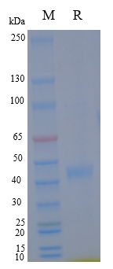
Figure 1 | On SDS-PAGE under reducing (R) condition. The gel was stained overnight with Coomassie Blue. The purity of the protein is greater than 90%.

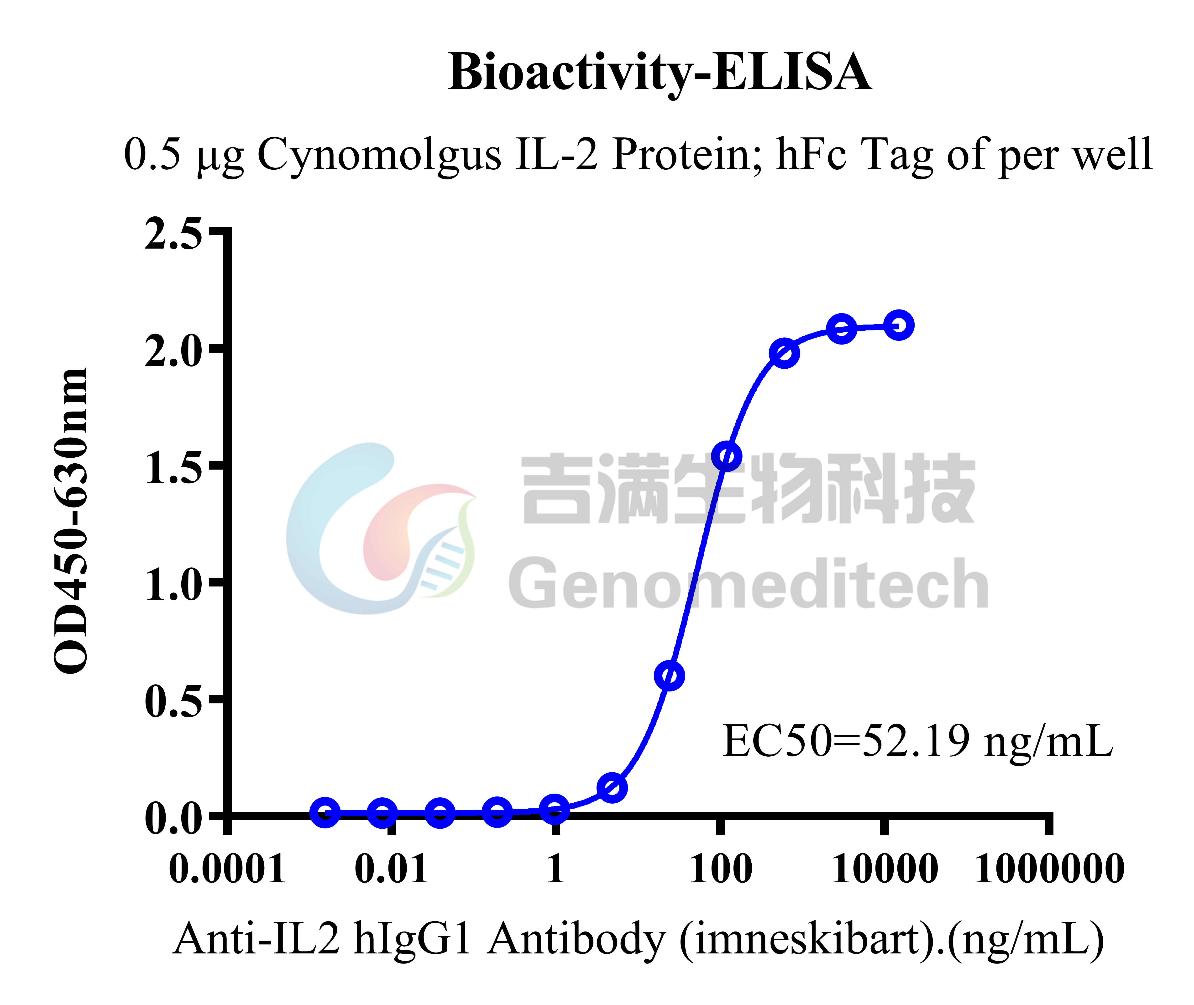
Figure 2 | Cynomolgus IL-2 Protein; hFc Tag (Catalog # GM-88751RP) was immobilized at 5 μg/ml (100 μL/well). Increasing concentrations of Anti-IL2 hIgG1 Antibody (imneskibart) (Catalog # GM-88653AB) were added.

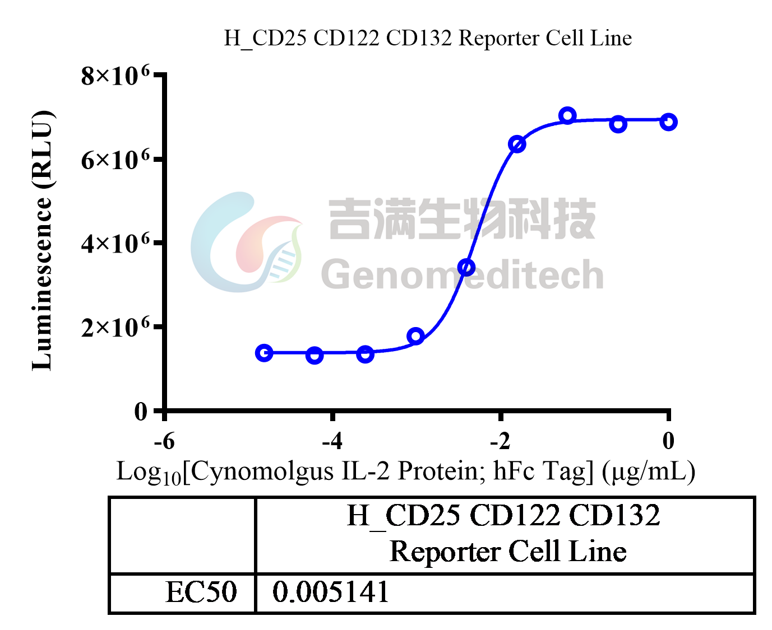
Figure 3 | Cynomolgus IL-2 Protein; hFc Tag (Catalog # GM-88751RP) was added into H_CD25 CD122 CD132 Reporter Cell Line (Catalog # GM-C29055) and stimulates related signals.

Related Products
IL-15
H_IL15 Reporter Cell Line | Cynomolgus_CD122 HEK-293 Cell Line
H_CD122 CD132 CHO-K1 Cell Line | H_CD122 CHO-K1 Cell Line
H_CD122 HEK-293 Cell Line | H_CD215(IL15RA) HEK-293 Cell Line
IL-2
H_CD122 CD132 Reporter 293 Cell Line | H_CD122 CD132 Reporter Cell Line
H_CD25 CD122 CD132 Reporter Cell Line | H_CD25 CD122 CD132 Reporter Jurkat(hPD1 OE) Cell Line
H_IL2 Reporter Cell Line | H_IL2 Reporter DDX35TM Cell Line
Cynomolgus_CD25 HEK-293 Cell Line | H_CD25 CHO-K1 Cell Line
H_CD25 HEK-293 Cell Line
Anti-CD122 hIgG1 Antibody(HuABC-2) | Anti-CD132(IL2RG) hIgG4 Antibody(REGN7257)
Anti-CD25 hIgG1 Antibody(Basiliximab) | Anti-IL2 hIgG1 Antibody (imneskibart)
Anti-mouse CD25 mIgG2a Antibody(PC-61.5.3) | Anti-mouse CD25 RIgG1 Antibody(PC-61.5.3)
Anti-PD1-IL2v Fusion hIgG1 Antibody(2149) | Anti-PD1-IL2v Fusion hIgG1 Antibody(KY-0118)
Cynomolgus IL-2 Protein; His Tag | Cynomolgus IL-2RA Protein; hFc Tag
Cynomolgus IL-2RA Protein; His Tag | Cynomolgus IL-2RB Protein; His Tag
Human IL-2 Protein; hFc Tag | Human IL-2 Protein; His Tag
Human IL-2RA Protein; His Tag | Human IL-2RB Protein; His Tag
Human IL-2RG Protein; His Tag

