Cynomolgus TSLPR Protein; His Tag

Product Information
Product Name | Cynomolgus TSLPR Protein; His Tag
Storage temp | Store at ≤ -70℃, stable for 6 months after receipt. Recommend to aliquot the protein into smaller quantities for optimal storage. Please minimize freeze-thaw cycles.
Catalog# / Size | GM-88813RP-100 / 100 μg  GM-88813RP-1000 / 1 mg

Protein Information
Alternative Names | TSLP R,CRLF2,IL-XR,ILXR,p2RY8,CRL2,CRLF2Y
Source | Cynomolgus TSLPR Protein; His Tag (GM-88813RP) is expressed from human 293 cells (HEK-293). It contains AA Tyr 29 - Gln 159 (Accession # A0A7N9CAT7).This protein carries a His tag at the C-terminus.
Purity | > 90% as determined by SDS-PAGE
Endotoxin | < 1 EU/μg, determined by LAL gel clotting assay
Predicted Mol Mass | 16.0 kDa
Formulation | Supplied as a 0.2 μm filtered solution of PBS, pH 7.2–7.4.
Description | TSLPR (Thymic Stromal Lymphopoietin Receptor) is a type of cell surface receptor protein that plays a crucial role in the immune system. It is an important component of the TSLP (Thymic Stromal Lymphopoietin) signaling pathway, involved in regulating the maturation and activation of immune cells. TSLPR is primarily expressed on dendritic cells, T cells, and other immune cells; by binding to TSLP, it promotes the regulation of immune responses, particularly in allergic and inflammatory reactions.  Furthermore, TSLPR has been confirmed to play an important role in the occurrence and development of certain diseases. Studies have shown that abnormal expression of TSLPR is related to immune disorders such as asthma and allergies, making it a potential therapeutic target. Its structural features include a classical extracellular ligand-binding domain and an intracellular signaling region, through which TSLPR can effectively mediate TSLP signal transduction and regulate immune system balance.

Figures
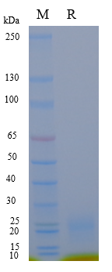
Figure 1 | On SDS-PAGE under reducing (R) condition. The gel was stained overnight with Coomassie Blue. The purity of the protein is greater than 90%.

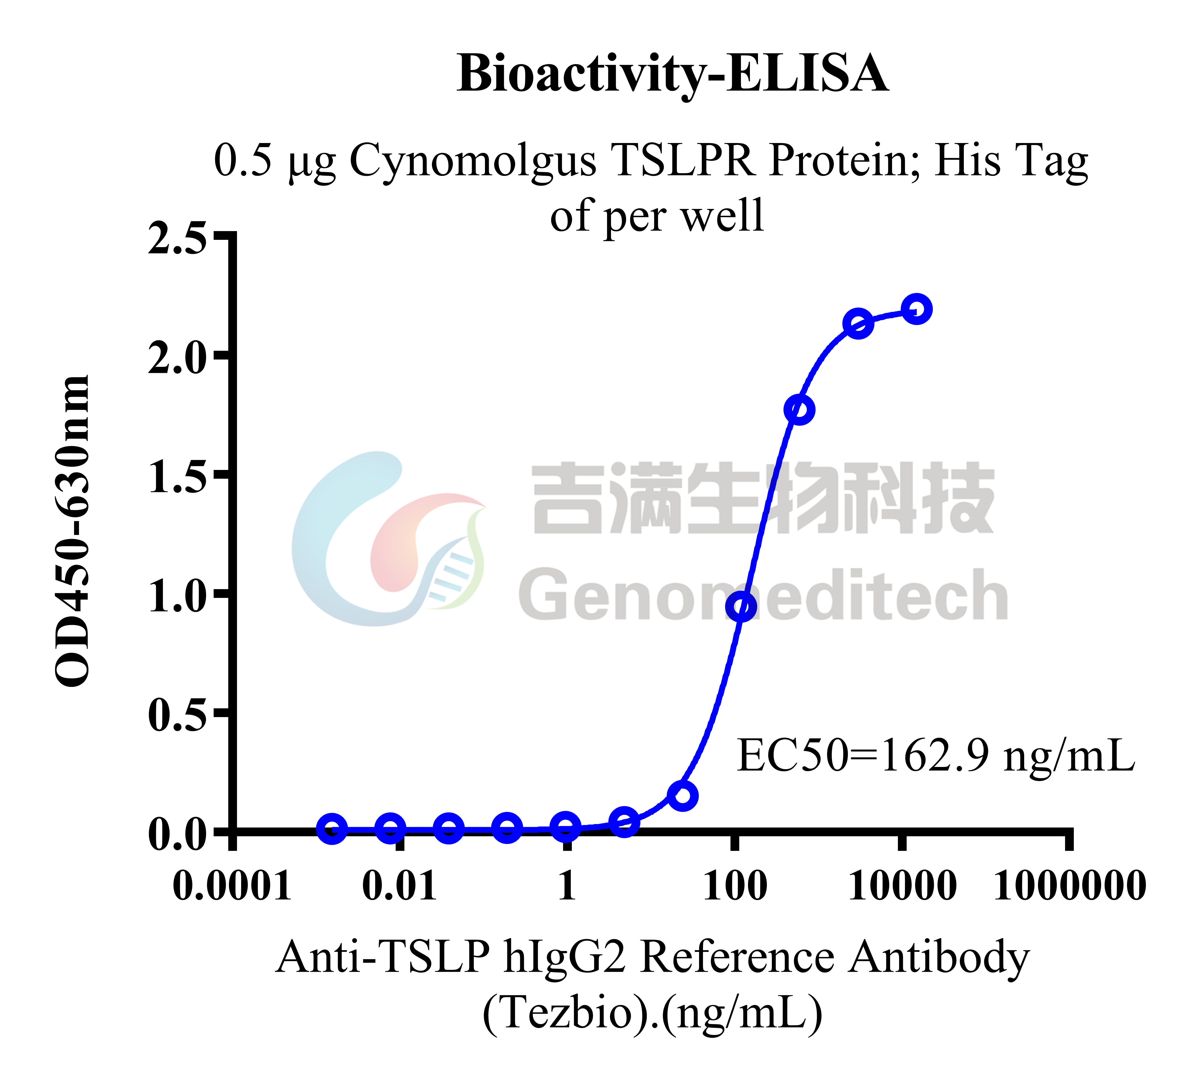
Figure 2 | Cynomolgus TSLPR Protein; His Tag (Catalog # GM-88813RP) was immobilized at 5 μg/ml (100 μL/well). Increasing concentrations of Anti-TSLP hIgG2 Reference Antibody (Tezbio) (Catalog # GM-87344AB) were added.

Related Products
IL-4/IL-13
IL-4 Reporter Cell Line | IL-4/IL-13 Reporter 293 Cell Line
IL-4/IL-13 Reporter 293 DDX35TM Cell Line | Cynomolgus_IL4R CHO-K1 Cell Line
H_IL4R CHO-K1 Cell Line | H_IL4R CHO-K1 Cell Line (Low Expression)
H_IL4R HEK-293 Cell Line | Mouse_IL4R CHO-K1 Cell Line
Anti-IL13 hIgG4 Reference Antibody (Lebribio) | Anti-IL-4R hIgG1 Antibody(12B5)
Anti-IL4R hIgG4 Antibody(Dupilumab) | Anti-IL4R hIgG4 Reference Antibody (Dupbio)
Anti-IL-4R×IL31 hIgG4 Reference Antibody (PRO2198) | Anti-Mouse IL-4RA mIgG1 Antibody
Biotinylated Human IL-4R alpha Protein; Avi-His Tag | Cynomolgus IL-13 Protein; His Tag
Cynomolgus IL-13RA1 Protein; His Tag | Cynomolgus IL-4 Protein; His Tag
Cynomolgus IL-4R alpha Protein; His Tag | Human IL-13 Protein; His Tag
Human IL-13RA1 Protein; hFc Tag | Human IL-13RA1 Protein; His Tag
Human IL-4 Protein; His Tag | Human IL-4R alpha Protein; hFc Tag
Human IL-4R alpha Protein; His Tag | Human IL-4R alpha Protein; mFc Tag
Mouse IL-13 Protein; His Tag | Mouse IL-4R alpha Protein; His Tag
Rat IL-4R alpha Protein; His Tag
TSLP:TSLPR
H_TSLP Reporter 293 Cell Line | H_TSLP Reporter Cell Line
H_TSLPR CHO-K1 Cell Line | H_TSLPR IL7RA BaF3 Cell Line
Anti-H_TSLPR hIgG1 Antibody | Anti-TSLP hIgG2 Antibody(Tezepelumab)
Anti-TSLP hIgG2 Reference Antibody (Tezbio)
Biotinylated Human TSLP Protein; His-Avi Tag | Cynomolgus TSLP Protein; His Tag
Human TSLP Protein; hFc Tag | Human TSLP Protein; His Tag
Human TSLPR Protein; hFc Tag | Human TSLPR Protein; His Tag
IL-5
H_IL-5 Reporter 293 Cell Line | Cynomolgus_IL-5RA HEK-293 Cell Line
H_IL-5RA CHO-K1 Cell Line | H_IL-5RA HEK-293 Cell Line
Anti-IL5 hIgG4 Antibody(Reslizumab) | Anti-IL-5R hIgG1 Antibody(Benralizumab)
Human IL-5 Protein; hFc Tag | Human IL-5 Protein; His Tag

