Human GPA33 Protein; His Tag

Product Information
Product Name | Human GPA33 Protein; His Tag
Storage temp | Store at ≤ -70℃, stable for 6 months after receipt. Recommend to aliquot the protein into smaller quantities for optimal storage. Please minimize freeze-thaw cycles.
Catalog# / Size | GM-88904RP-100 / 100 μg  GM-88904RP-1000 / 1 mg

Protein Information
Alternative Names | A33
Source | Human GPA33 Protein; His Tag (GM-88904RP) is expressed from human 293 cells (HEK-293). It contains AA Ile 22 - Val 235 (Accession # AAH74830.1).  This protein carries a His tag at the C-terminus.
Purity | > 90% as determined by SDS-PAGE
Endotoxin | < 1 EU/μg, determined by LAL gel clotting assay
Predicted Mol Mass | 24.4 kDa
Formulation | Supplied as a 0.2 μm filtered solution of PBS, pH 7.2–7.4.
Description | Glycoprotein A33 (GPA33), known as the A33 antigen, is a single-pass type I transmembrane glycoprotein of the Ig superfamily, encoded by GPA33 at 1q24.1. Its extracellular region contains two Ig-like domains characteristic of the CD2 subgroup, and the protein is N-glycosylated and palmitoylated. Although its physiological function remains incompletely defined, GPA33 has been implicated in cell–cell recognition and signaling. It is largely restricted to normal gastrointestinal epithelium but retained in over 95% of colorectal cancers, rendering it a promising biomarker and therapeutic target.

Figures
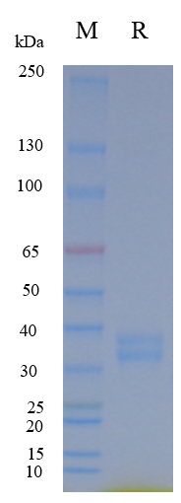
Figure 1 | On SDS-PAGE under reducing (R) condition. The gel was stained overnight with Coomassie Blue. The purity of the protein is greater than 90%.

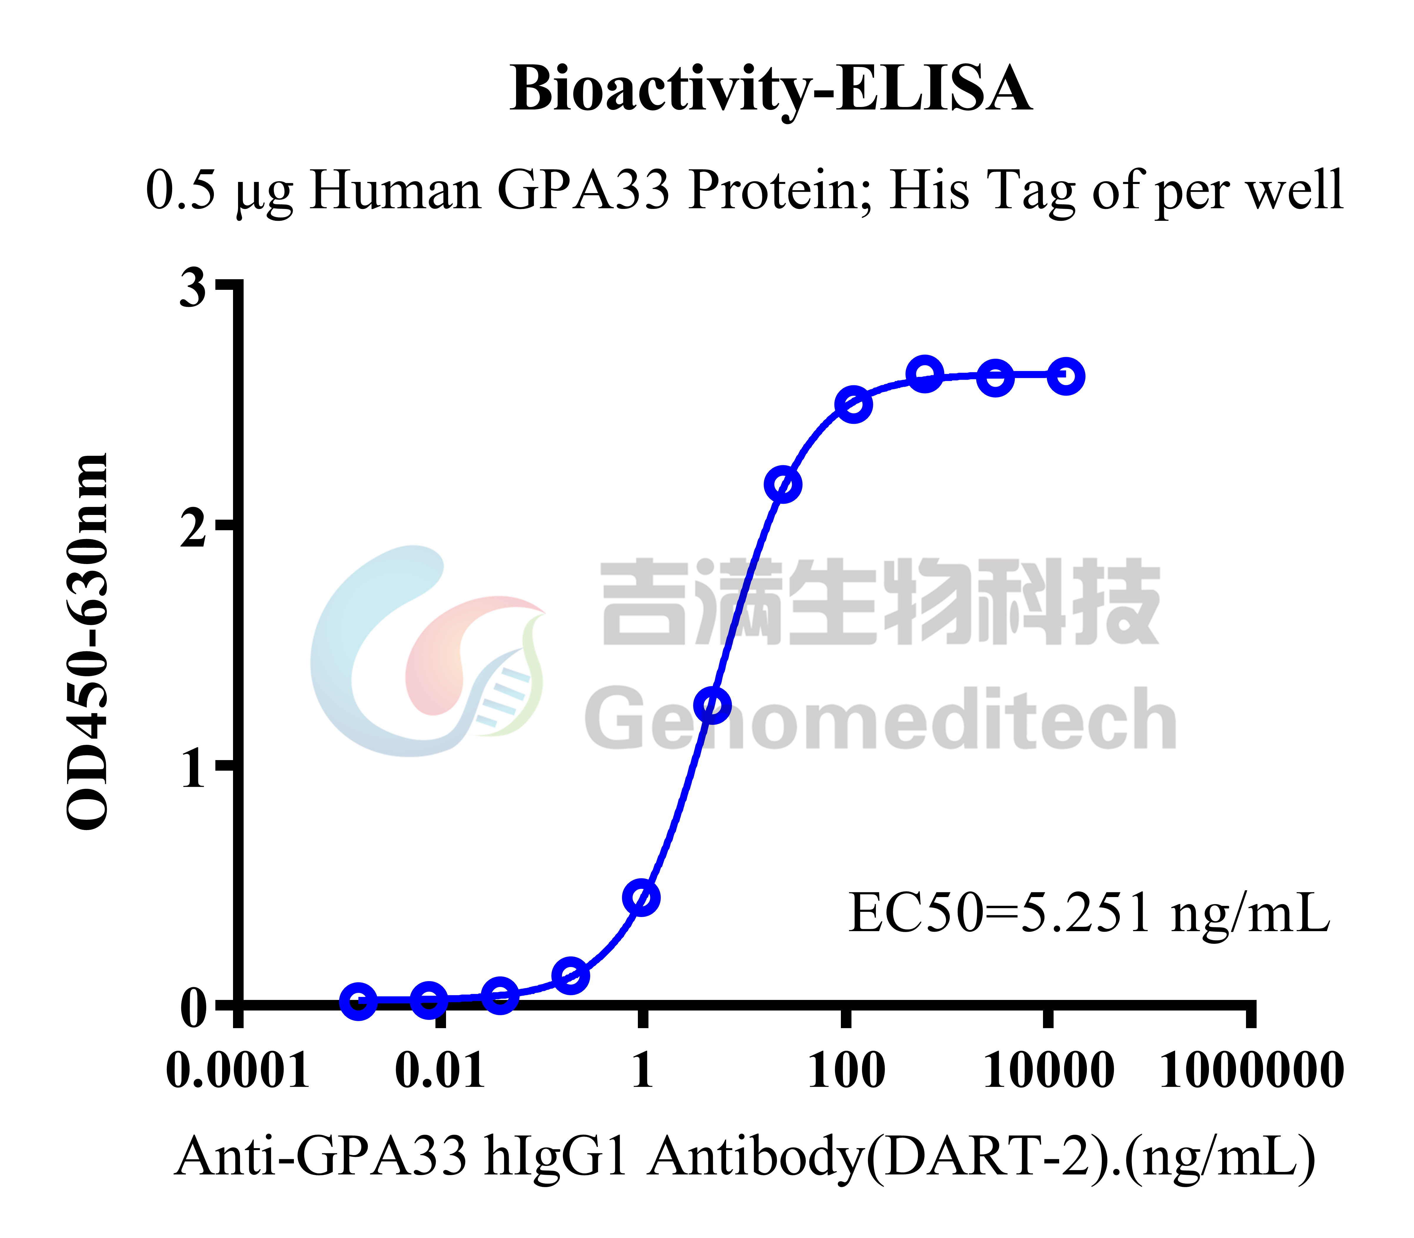
Figure 2 | Human GPA33 Protein; His Tag (Catalog # GM-88904RP) was immobilized at 5 μg/ml (100 μL/well). Increasing concentrations of Anti-GPA33 hIgG1 Antibody(DART-2) (Catalog # GM-52271AB) were added.

Related Products
GPA33
Cynomolgus_GPA33 CHO-K1 Cell Line | H_GPA33 CHO-K1 Cell Line
H_GPA33 CT26 Cell Line | H_GPA33 HEK-293 Cell Line
Anti-GPA33 hIgG1 Antibody(DART-2) | Anti-H_GPA33 hIgG1 Antibody(A2)

