Human LILRB2 Protein; His Tag

Product Information
Product Name | Human LILRB2 Protein; His Tag
Storage temp | Store at ≤ -70℃, stable for 6 months after receipt. Recommend to aliquot the protein into smaller quantities for optimal storage. Please minimize freeze-thaw cycles.
Catalog# / Size | GM-88898RP-100 / 100 μg  GM-88898RP-1000 / 1 mg

Protein Information
Alternative Names | ILT4, LIR2, MIR10, CD85d
Source | Human LILRB2 Protein; His Tag (GM-88898RP) is expressed from human 293 cells (HEK-293). It contains AA Gln 22 - Val 461 (Accession # AAH36827.1). This protein carries a His tag at the C-terminus.
Purity | > 90% as determined by SDS-PAGE
Endotoxin | < 1 EU/μg, determined by LAL gel clotting assay
Predicted Mol Mass | 48.6 kDa
Formulation | Supplied as a 0.2 μm filtered solution of PBS, pH 7.2–7.4.
Description | Leukocyte immunoglobulin-like receptor subfamily B member 2 (LILRB2, also known as ILT4 or CD85d) is a type I transmembrane inhibitory receptor encoded within the leukocyte immunoglobulin-like receptor (LIR) gene cluster on chromosome 19q13.4. The protein comprises four extracellular immunoglobulin-like domains and a cytoplasmic tail harboring three immunoreceptor tyrosine-based inhibitory motifs (ITIMs). Upon ligand engagement, LILRB2 recruits the Src homology 2 domain-containing phosphatase SHP-1 via its ITIMs and transduces inhibitory signals that suppress immune activation. Functionally, LILRB2 limits inflammatory responses and cytotoxicity, promotes immune tolerance (including maternal-fetal tolerance) through the induction of regulatory T cells and myeloid-derived suppressor cells, and facilitates tumor immune evasion, making it an emerging target for cancer immunotherapy.

Figures
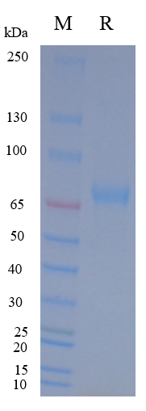
Figure 1 | On SDS-PAGE under reducing (R) condition. The gel was stained overnight with Coomassie Blue. The purity of the protein is greater than 90%.

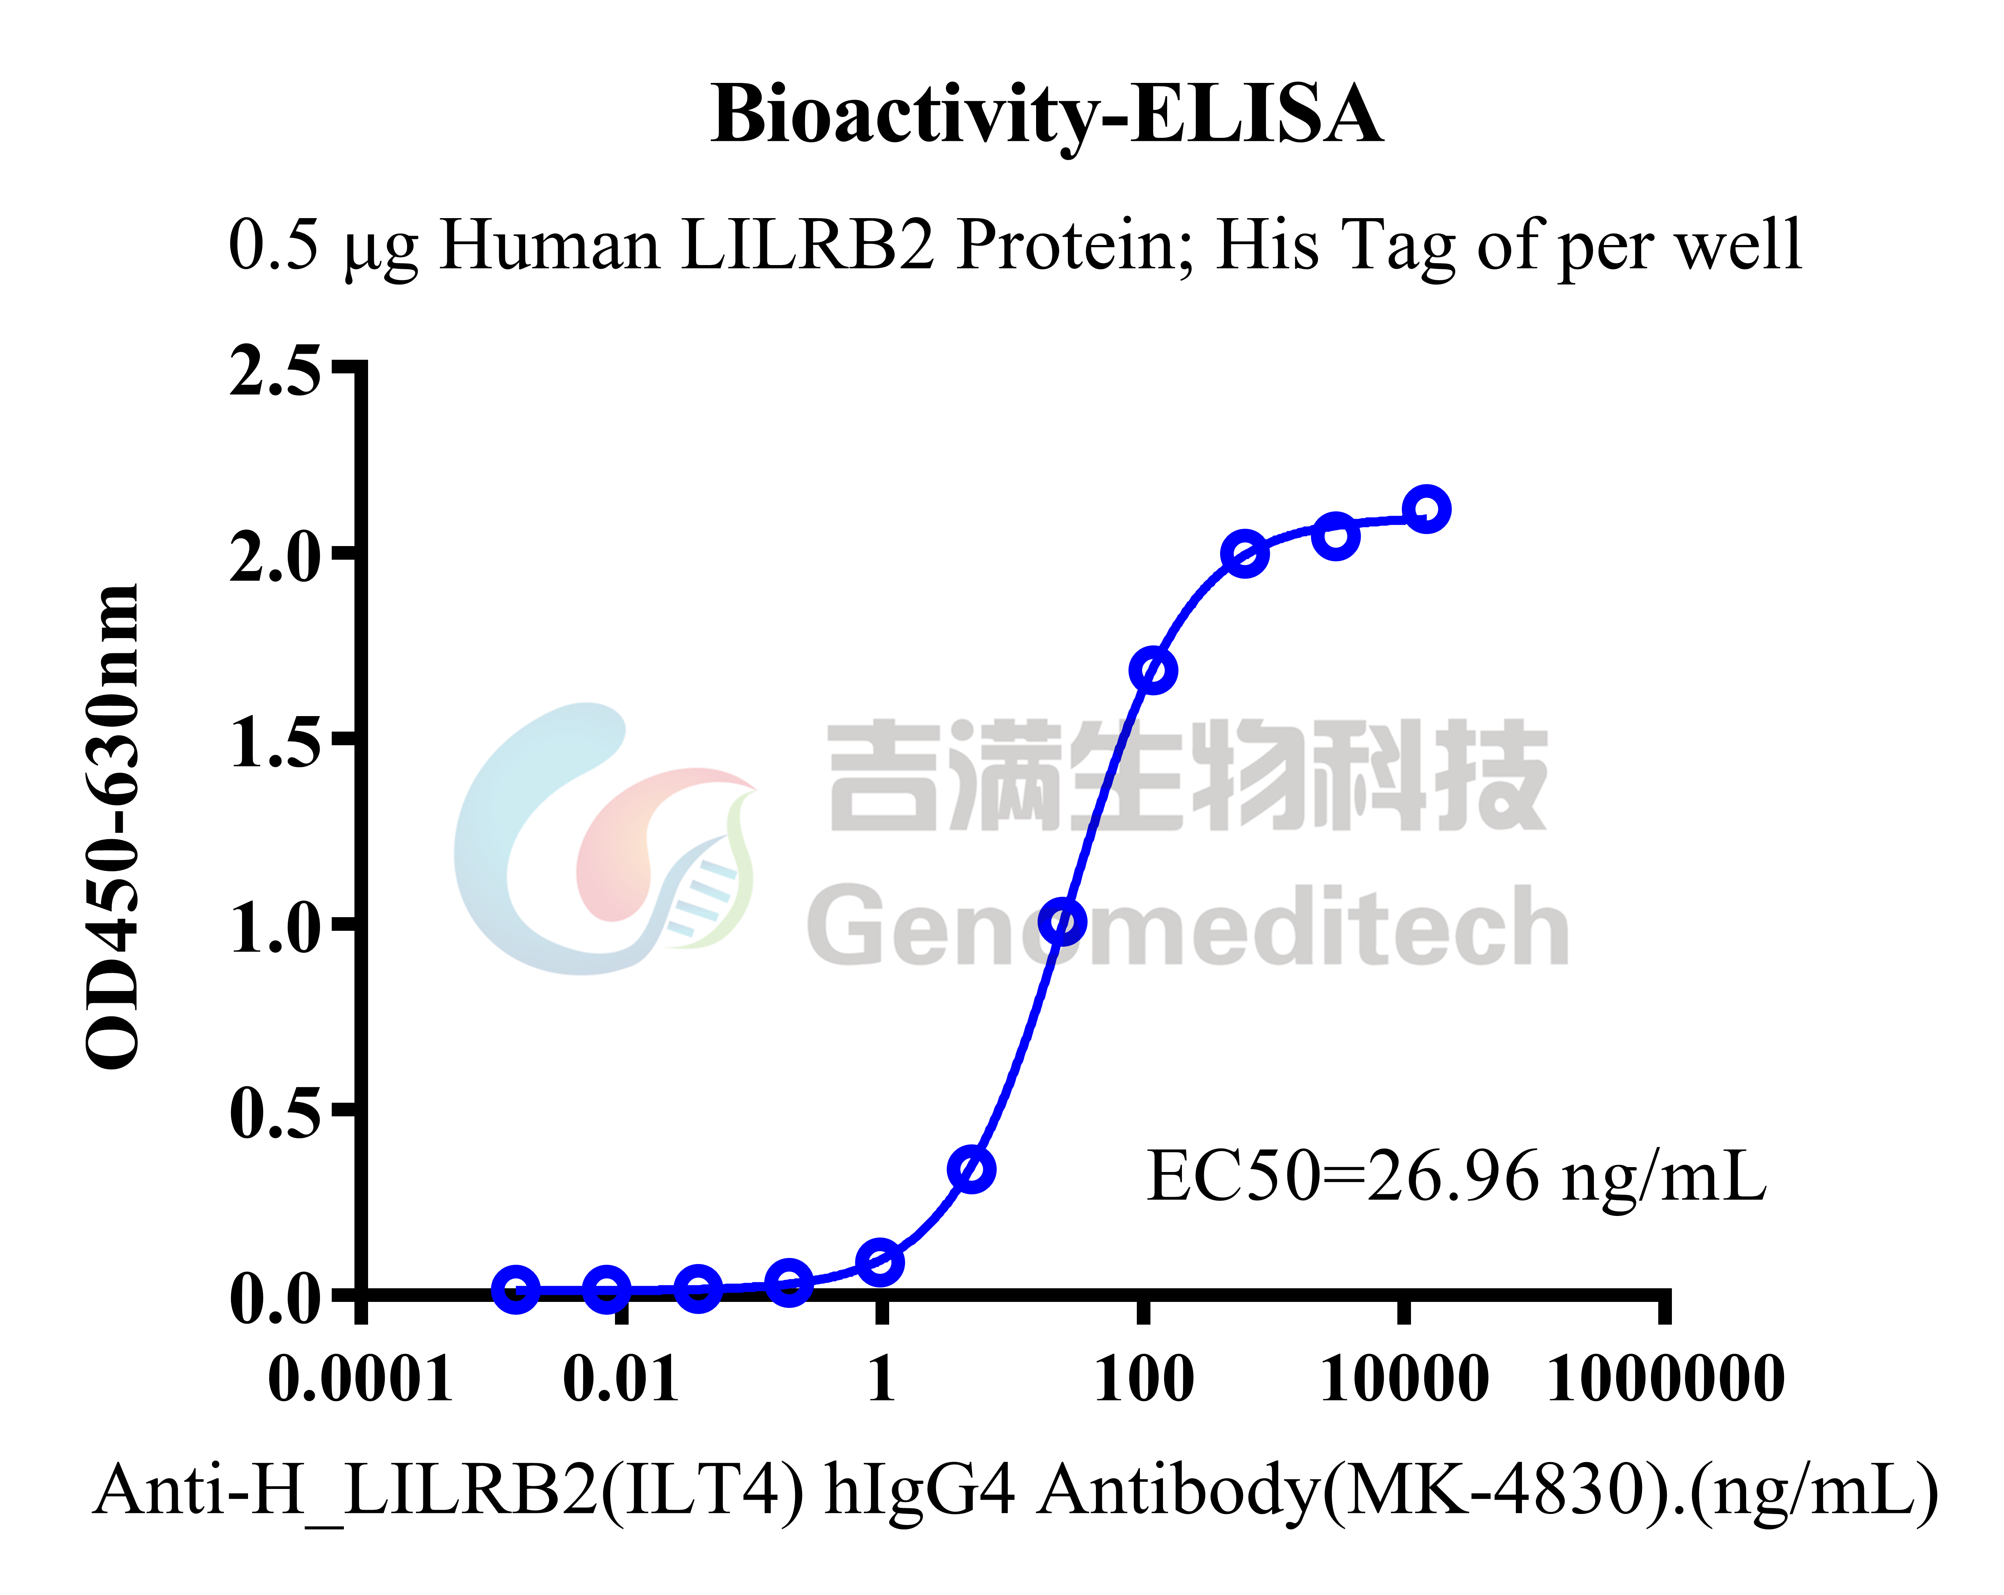
Figure 2 | Human LILRB2 Protein; His Tag (Catalog # GM-88898RP) was immobilized at 5 μg/ml (100 μL/well). Increasing concentrations of Anti-H_LILRB2(ILT4) hIgG4 Antibody(MK-4830) (Catalog # GM-27362AB) were added.

Related Products
LILRB2(ILT4)
H_LILRB2(ILT4) Reporter Jurkat Cell Line | H_LILRB2(ILT4) CHO-K1 Cell Line
H_LILRB2(ILT4) HEK-293 Cell Line
Anti-H_LILRB2(ILT4) hIgG4 Antibody(MK-4830)
LILRB1(ILT2)
H_LILRB1(ILT2) Reporter Jurkat Cell Line | H_LILRB1(ILT2) CHO-K1 Cell Line
H_LILRB1(ILT2) HEK-293 Cell Line | Rhesus_LILRB1 CHO-K1 Cell Line
Anti-LILRB1(ILT2) mIgG1 Antibody(12D12)
Human LILRB1(ILT2) Protein; hFc Tag(D9IDM8-1) | Human LILRB1(ILT2) Protein; His Tag(D9IDM8-1)
Human LILRB1(ILT2) Protein; His Tag(Q8NHL6-1)
LILRB4(ILT3)
H_LILRB4(ILT3) CHO-K1 Cell Line | H_LILRB4(ILT3) HEK-293 Cell Line
LILRB5
H_LILRB5 CHO-K1 Cell Line
LILRB3(ILT5)
H_LILRB3 Reporter Jurkat Cell Line | H_LILRB3(ILT5) CHO-K1 Cell Line
H_LILRB3(ILT5) HEK-293 Cell Line
Anti-LILRB3 hIgG1 Antibody(7C5)

