Human LILRB1(ILT2) Protein; hFc Tag(D9IDM8-1)

Product Information
Product Name | Human LILRB1(ILT2) Protein; hFc Tag(D9IDM8-1)
Storage temp | Store at ≤ -70℃, stable for 6 months after receipt. Recommend to aliquot the protein into smaller quantities for optimal storage. Please minimize freeze-thaw cycles.
Catalog# / Size | GM-88762RP-100 / 100 μg  GM-88762RP-1000 / 1 mg

Protein Information
Alternative Names | CD85J, LILRB1, CD85, ILT2, LIR1, MIR7
Source | Human LILRB1(ILT2) Protein; hFc Tag (D9IDM8-1) (GM-88762RP) is expressed from human 293 cells (HEK-293). It contains AA Gly 24 - His 458 (Accession # D9IDM8).This protein carries a hFc tag at the C-terminus.
Purity | > 90% as determined by SDS-PAGE
Endotoxin | < 1 EU/μg, determined by LAL gel clotting assay
Predicted Mol Mass | 73.1 kDa
Formulation | Supplied as a 0.2 μm filtered solution of PBS, pH 7.2–7.4.
Description | LILRB1 is a transmembrane receptor expressed on monocytes, dendritic cells, B cells, T cells, and NK cells. It belongs to the leukocyte immunoglobulin-like receptor (LILR) family and functions as an inhibitory receptor. LILRB1 has ITIMs in its cytoplasmic tail that recruit phosphatases such as SHP-1/2 upon engagement, dampening activating signals and maintaining immune tolerance. Ligands include classical and non-classical MHC I molecules (e.g., HLA-G, HLA-E) and certain viral proteins.  LILRB1 ITIMs recruit SHP-1/2 upon ligand binding, leading to dephosphorylation of signaling intermediates and attenuation of PI3K/AKT and MAPK pathways. Inhibition reduces NK cell cytotoxicity, modulates dendritic cell maturation, and affects T cell activation and cytokine production. Crosstalk with other receptors tunes responses, balancing tolerance and immunity. Dysregulation of LILRB1 signaling is linked to tumor immune evasion and chronic infections, shaping adaptive and innate immunity.

Figures
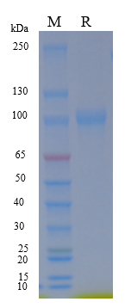
Figure 1 | On SDS-PAGE under reducing (R) condition. The gel was stained overnight with Coomassie Blue. The purity of the protein is greater than 90%.

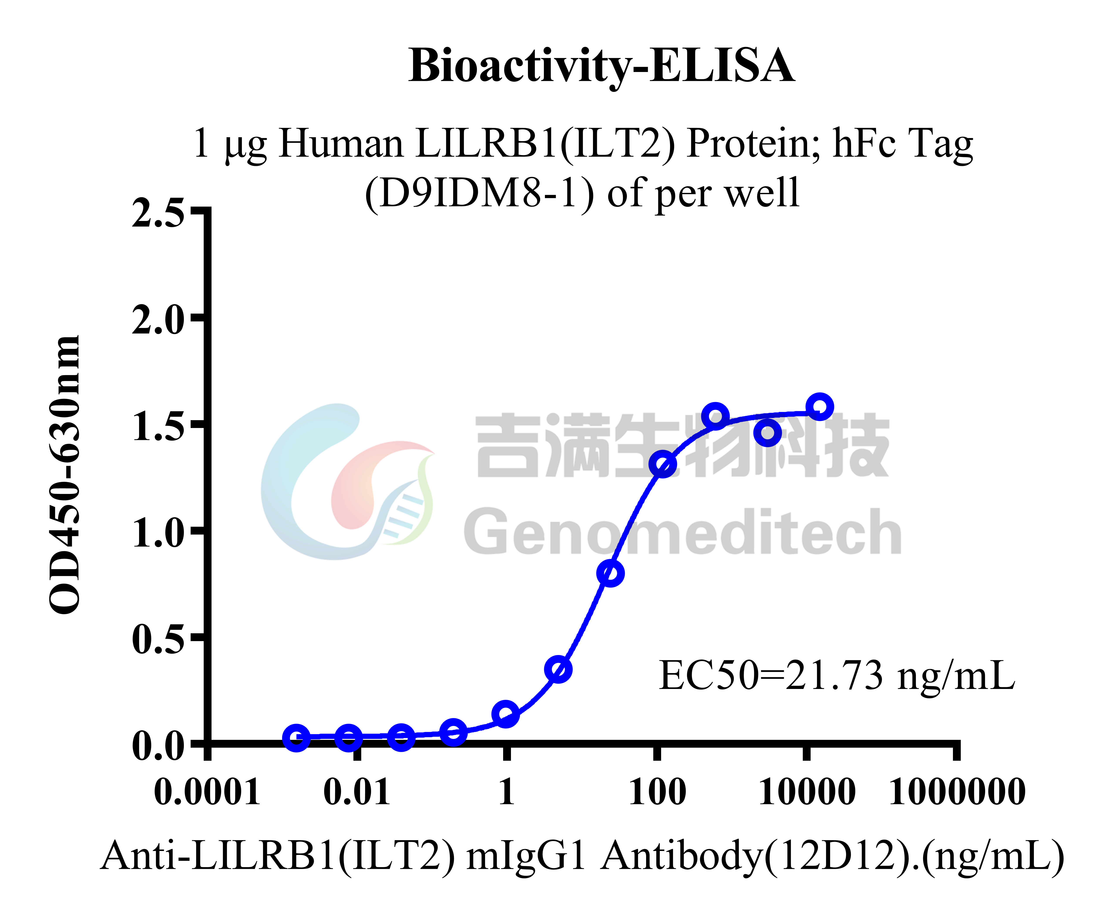
Figure 2 | Human LILRB1(ILT2) Protein; hFc Tag(D9IDM8-1) (Catalog # GM-88762RP) was immobilized at 10 μg/ml (100 μL/well). Increasing concentrations of Anti-LILRB1(ILT2) mIgG1 Antibody(12D12) (Catalog # GM-27366AB) were added.

Related Products
LILRB2(ILT4)
H_LILRB2(ILT4) Reporter Jurkat Cell Line | H_LILRB2(ILT4) CHO-K1 Cell Line
H_LILRB2(ILT4) HEK-293 Cell Line
Anti-H_LILRB2(ILT4) hIgG4 Antibody(MK-4830)
LILRB1(ILT2)
H_LILRB1(ILT2) Reporter Jurkat Cell Line | H_LILRB1(ILT2) CHO-K1 Cell Line
H_LILRB1(ILT2) HEK-293 Cell Line | Rhesus_LILRB1 CHO-K1 Cell Line
Anti-LILRB1(ILT2) mIgG1 Antibody(12D12)
Human LILRB1(ILT2) Protein; His Tag(D9IDM8-1) | Human LILRB1(ILT2) Protein; His Tag(Q8NHL6-1)
HLA-G
H_HLA-G1 CHO-K1 Cell Line | H_HLA-G1 HEK-293 Cell Line
H_HLA-G1 MC38 Cell Line | H_HLA-G1 OKT3 CHO-K1 Cell Line
H_HLA-G1 PDL1 MC38(mouse_PDL1 KO) Cell Line | H_HLA-G1 SK-OV3 Cell Line
Rhesus_MAMU-AG HEK-293 Cell Line
Anti-H_HLA-G1 hIgG1 Antibody(38373)
LILRB4(ILT3)
H_LILRB4(ILT3) CHO-K1 Cell Line | H_LILRB4(ILT3) HEK-293 Cell Line
LILRB5
H_LILRB5 CHO-K1 Cell Line
LILRB3(ILT5)
H_LILRB3 Reporter Jurkat Cell Line | H_LILRB3(ILT5) CHO-K1 Cell Line
H_LILRB3(ILT5) HEK-293 Cell Line
Anti-LILRB3 hIgG1 Antibody(7C5)

